LAB 09

TASK01

When semaphore (s) = 1 thread=3
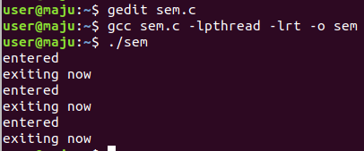

When semaphore (s)=5 thread=3
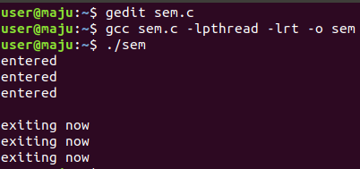

Task 2:
